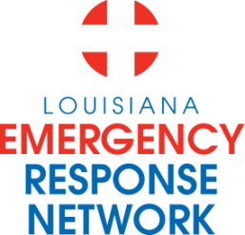

Louisiana Emergency Response Network
Board Meeting
March 21, 2013
2:00pm – 4:00pm
Location: Louisiana Emergency Response Network - Headquarters
14141 Airline Hwy, Suite One, Suite B Baton Rouge, LA 70817

AGENDA
1. Welcome and Introduction of New and Current LERN Board Members
2. Roll Call and Establish a Quorum
3. Approval of Agenda
4. Approval of Minutes of January 24th Board Meeting
5. LERN Business:
- Executive Director Report/Annual Report P. Hargrove
b. Ratification of Commission Members P. Hargrove
c. Update STEMI –Present Protocols/Discuss Registry: M. Ali, MD
- LERN STEMI Receiving Center Requirements
- STEMI Flow Chart
- STEMI Triage Protocol
- Thrombolysis Guideline for STEMI Referral Centers

d. Stroke – Present Protocol: K. Gaines, MD
- LERN Stroke Care Protocol
- LERN Levels
e. Executive Budget: LERN/BEMS Integration P. Hargrove
f. Budget/Finance P. Sullivan/C. Barr
g. LERN Medical Director Report R. Coscia, MD
h. Contract, Robert Coscia P. Hargrove
j. Vice - Chairman’s Closing Remarks John Hunt, MD

6. Public Comment
7. Adjournment

NEXT BOARD MEETING DATE – May 16, 2013
2 -4 p.m. LERN Office, Baton Rouge La

